**HOW TO CONNECT TO DATABASE - POSTGRES**

**NOTE : DON’T CONNECT WITH TCD WIFI**

1. Download PgAdmin (Choose according to your OS) - <https://www.pgadmin.org/download/>
2. Install PgAdmin
3. Go to server and right click -> Click on Register -> Click on Server (See Image Below)
4. 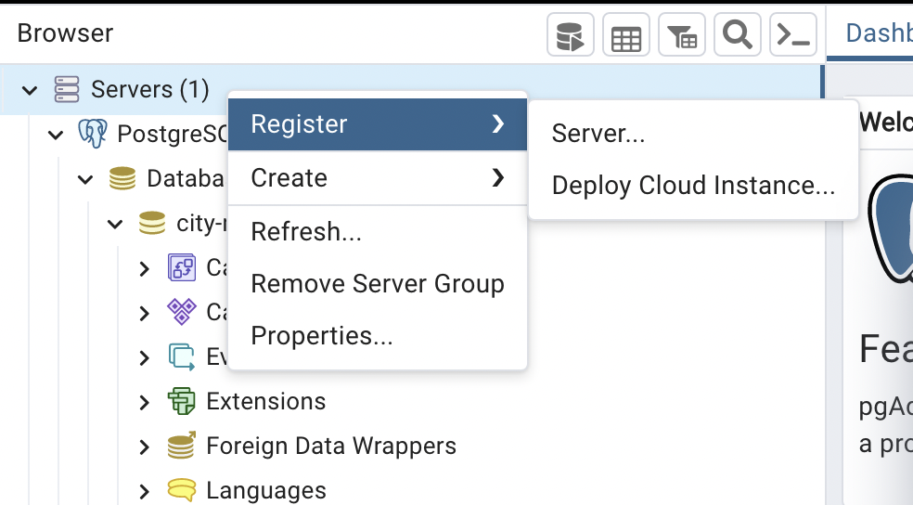
5. The following box will open (below) -> Go to connection tab and enter the following details :

**Endpoint/Address/HostName:** sustainable-city-management.cdxqy8kbzxjs.eu-west-1.rds.amazonaws.com

**Port:** 5432

**DB name:** masterdb

**Master username:** group_admin

**Master password :** group007

